1)
x=c(10.1,7.3,8.5,5.0,4.2,3.1,2.2,9.0,9.4,6.1,3.3,10.7,1.5,8.2,10.0,4.7,3.5,6.5,8.9,6.1)
table(cut(x, breaks = seq(from = 1, to = 11, length = 6)))
hist(x, breaks = seq(from = 1, to = 11, length = 6))
y= c(3.3,10.7,1.5,8.2,10.0,4.7,3.5,6.5,8.9,6.1)
mean(y)
median(y)
sd(y)

> x=c(10.1,7.3,8.5,5.0,4.2,3.1,2.2,9.0,9.4,6.1,3.3,10.7,1.5,8.2,10.0,4.7,3.5,6.5,8.9,6.1)
> table(cut(x, breaks = seq(from = 1, to = 11, length = 6)))

(1,3] (3,5] (5,7] (7,9] (9,11]
2 6 3 5 4
> hist(x, breaks = seq(from = 1, to = 11, length = 6))

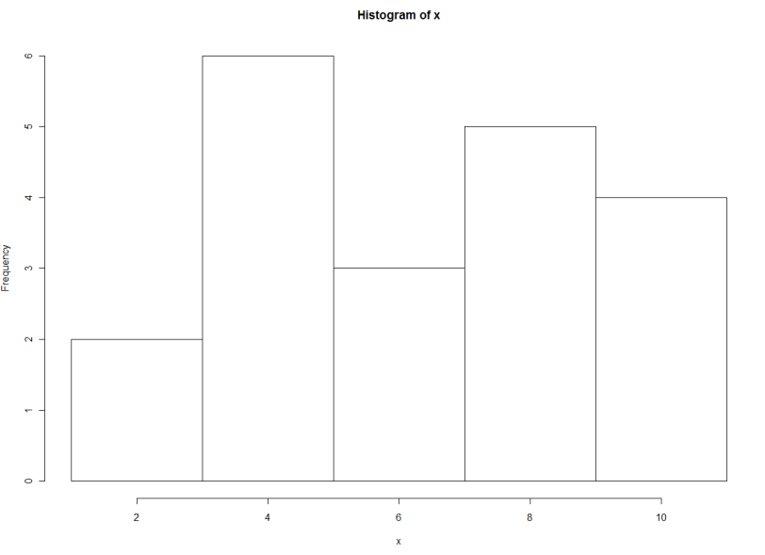

> y= c(3.3,10.7,1.5,8.2,10.0,4.7,3.5,6.5,8.9,6.1)
> mean(y)
[1] 6.34
> median(y)
[1] 6.3

> sd(y)
[1] 3.08984
>

2)
X=c(2, 3, 2, 1, 2, 1, 2, 1, 2, 3, 1, 1, 1, 2, 2, 3, 1, 1, 1, 1, 2, 1, 1, 2, 2, 1, 2, 1, 2, 3, 2, 3, 2, 1, 2, 1, 2, 1, 2, 3, 1)
Y=table(X)
barplot(Y)

> X=c(2, 3, 2, 1, 2, 1, 2, 1, 2, 3, 1, 1, 1, 2, 2, 3, 1, 1, 1, 1, 2, 1, 1, 2, 2, 1, 2, 1, 2, 3, 1, 1, 2, 2, 3, 1, 1, 1, 1, 2, 1)
> Y=table(X)
> barplot(Y)
>
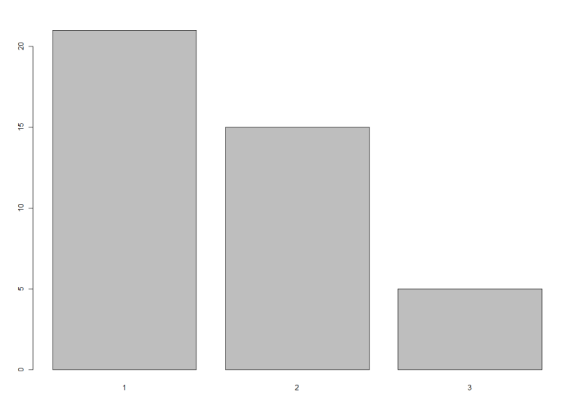
3)
X=c("superior","superior","médio","médio","médio","médio","médio","médio","fundamental","fundamental")
table(X)
barplot(table(X))

> X=c("superior","superior","médio","médio","médio","médio","médio","médio","fundamental","fundamental")
> table(X)
X
fundamental médio superior
2 6 2
> barplot(table(X))
>
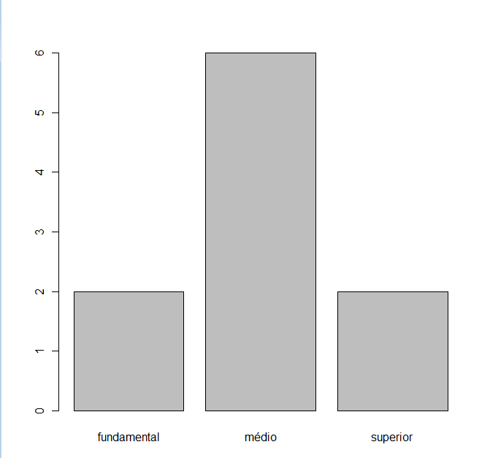
x=c(34,43,31,37,24,25,27,22,21,26)
table(cut(x, breaks = seq(from = 20, to = 45, length = 6)))
hist(x, breaks = seq(from = 20, to = 45, length = 6))
> x=c(34,43,31,37,24,25,27,22,21,26)
> table(cut(x, breaks = seq(from = 20, to = 45, length = 6)))

(20,25] (25,30] (30,35] (35,40] (40,45]
4 2 2 1 1
> hist(x, breaks = seq(from = 20, to = 45, length = 6))
>
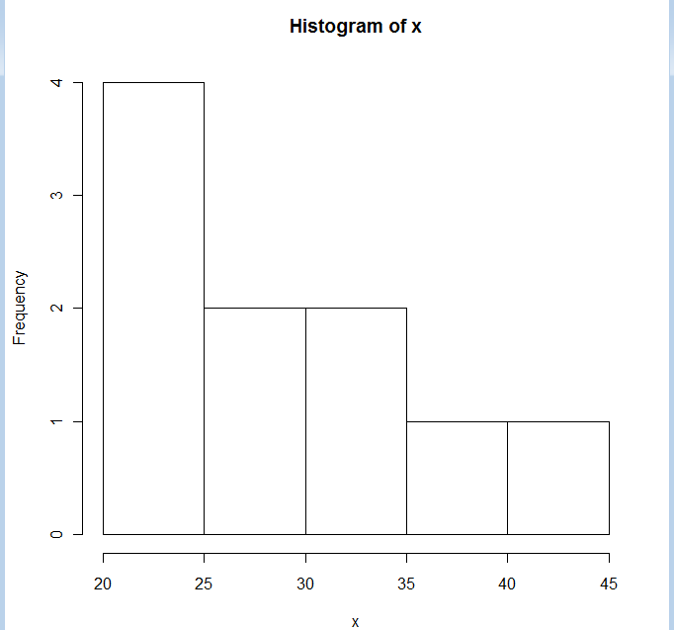

4)
a) 10.000
b) 9.000
c)7.500
d) 1.000
e) 16
f) {16/65=0.2461538} 24,62%
g) 3ª classe
h) 18/65*100 = 27,69%
i) (8+10+16+14+10)/65*100 =89.23 %
(8+10)/65*100 = 27,69%
j)
 | FR | Percentual
8 | 0,12 | 12,31
10 | 0,15 | 15,38
16 | 0,25 | 24,62
14 | 0,22 | 21,54
10 | 0,15 | 15,38
5 | 0,08 | 7,69
2 | 0,03 | 3,08
65

